EX:3 | EXPLORATORY DATA ANALYSIS (EDA) – DATA CLEANING AND DATA TRANSFORMATION
DATE:

AIM:

To identify and handle missing values, duplicate records, outliers, inconsistent data, and perform data transformation techniques such as normalization and encoding using Python Pandas.

ALGORITHM:

Step 1: Import the required Python libraries such as Pandas and NumPy.
Step 2: Load the dataset using the appropriate Pandas function.
Step 3: Display the first few records to understand the dataset.
Step 4: Check the dataset structure using info() and describe().
Step 5: Identify missing values using the isnull() function.
Step 6: Count the total number of missing values in each column.
Step 7: Handle missing values by removing them or replacing them with appropriate values (mean, median, mode, or a constant).
Step 8: Detect duplicate records using the duplicated() function.
Step 9: Remove duplicate records using the drop_duplicates() function.
Step 10: Correct inconsistent or invalid data values, if any.
Step 11: Verify that the dataset is clean by checking for remaining missing values and duplicates.
Step 12: Display the cleaned dataset.
Step 13: End the program.

PROGRAM:

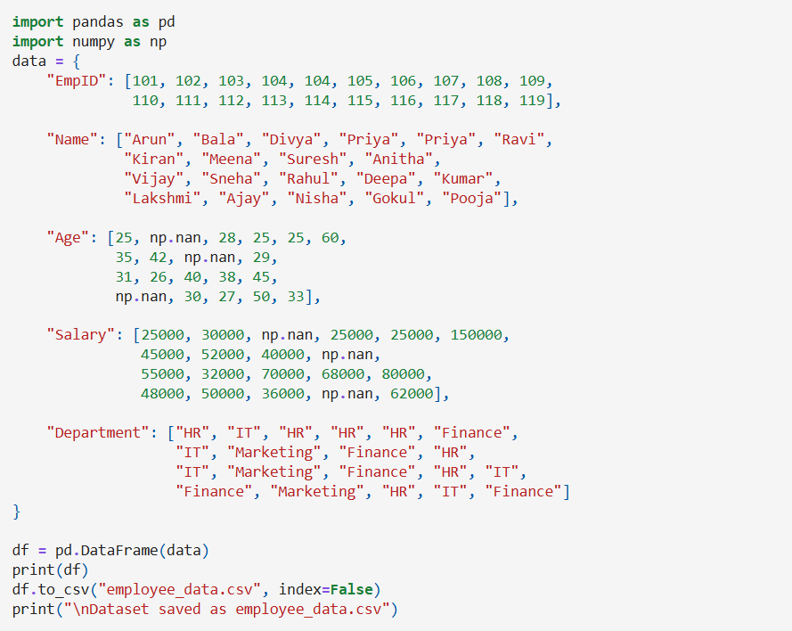

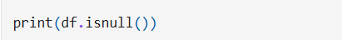

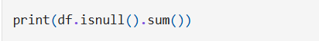

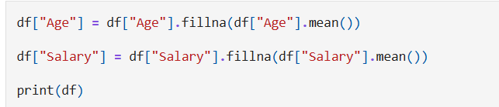

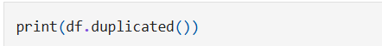

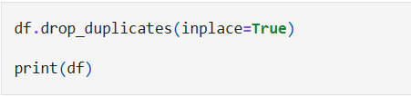

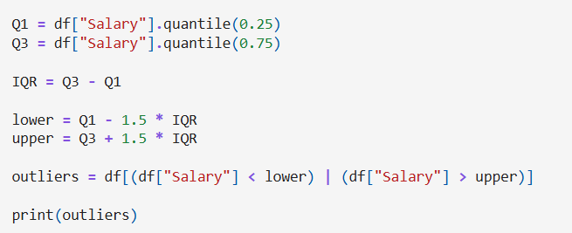

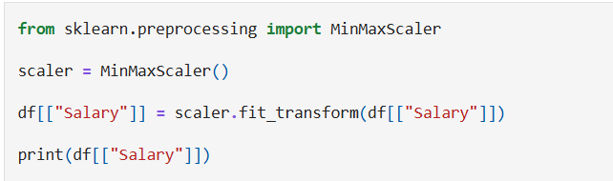

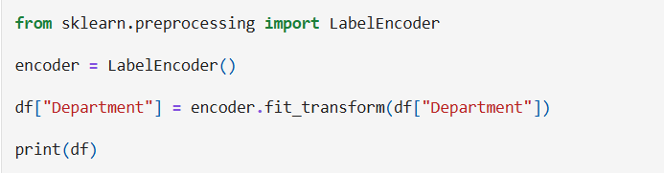

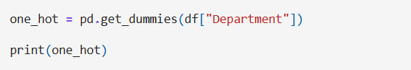

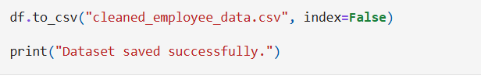

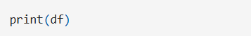
OUTPUT:

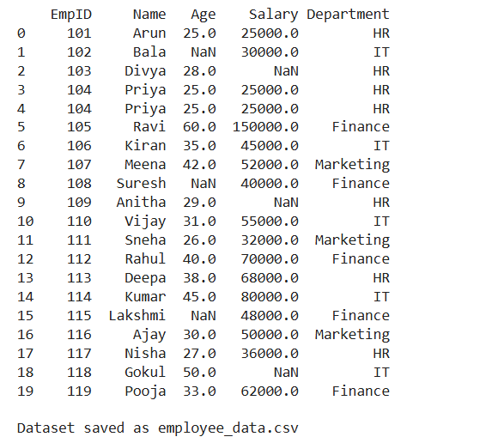

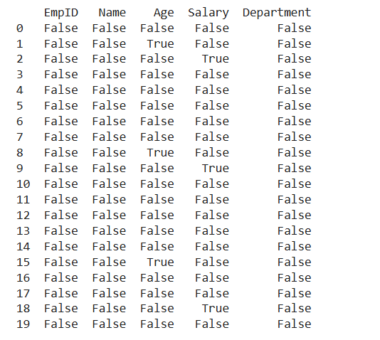

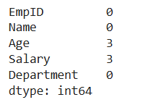

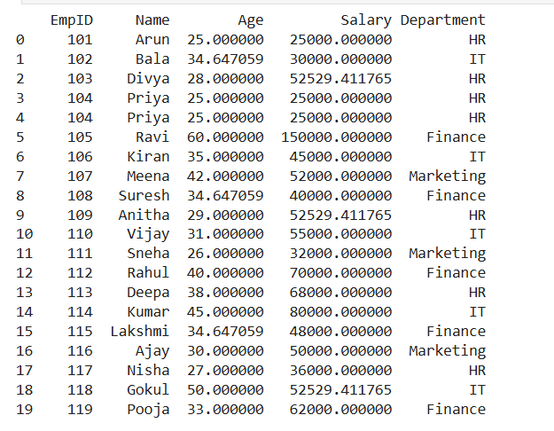

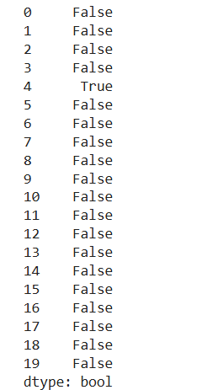



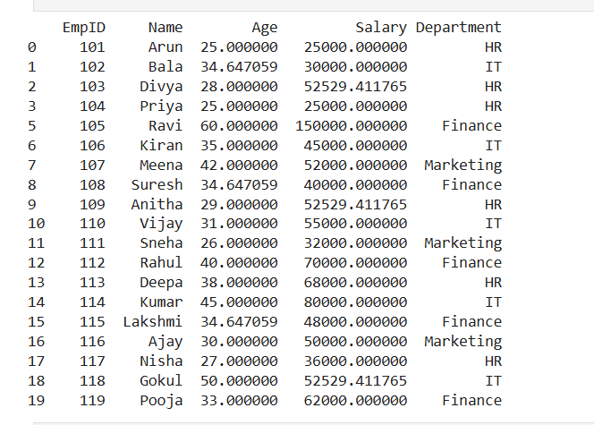

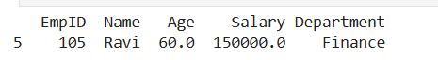

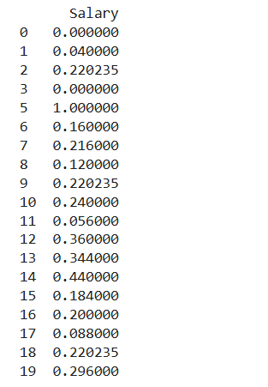

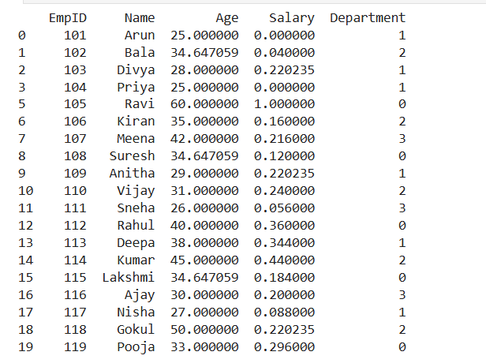

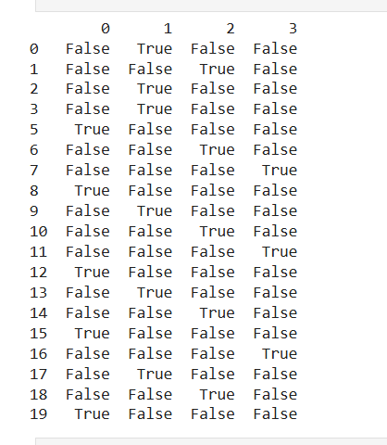

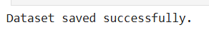

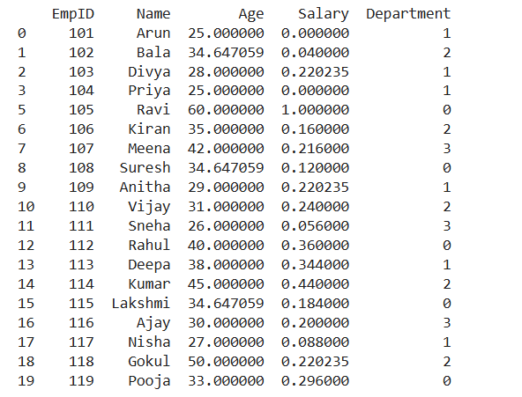

RESULT:

The dataset was successfully analyzed for missing values and cleaned by handling missing data, removing duplicate records, and correcting inconsistencies. The cleaned dataset was verified to ensure data quality. Thus, the dataset was prepared successfully for further analysis and processing.

